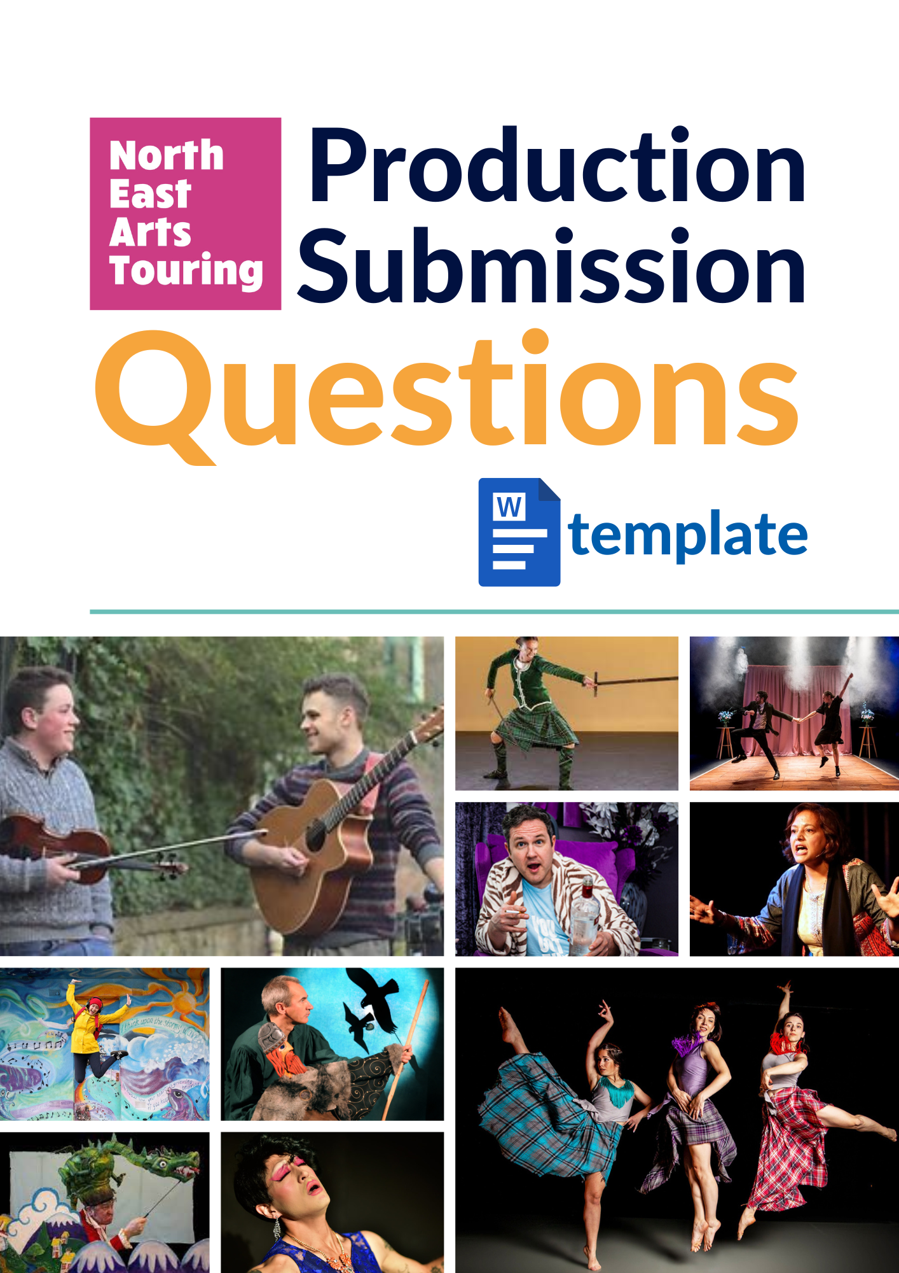
Contents
Purpose and How to Use This Template 1
Contact Details 2
Production Information 3
Publicity Material 5
Fee & Workshops 8
Touring Dates & Other Venues 9
Technical Information 11
Accessibility & Sustainability 13
Further Information 15

Version 2 May 2026

Purpose and How to Use This Template
This Word document is provided to make the submission process as accessible and straightforward as possible.
We understand that some find online forms difficult to navigate, and text boxes can be small or confusing. This template allows you to prepare your answers in a more comfortable format before submitting them online.
This is your template for the information we require, so please use it in a way that works best for you.

How to Use This Template:
- Use this document to type out your answers to each question at your own pace.
- Once you’re happy with your responses, copy and paste them into the corresponding fields in the online submission form.
- Please note: You must submit your answers via the online form. Do not email this document to us.
- If you experience any difficulties with the online form, please get in touch with Emyr for support.

Important Notes:
- Questions marked in red are text-based. You’ll see a placeholder like “Type your answer here” - simply overtype this with your response.
- Word or character limits are indicated where applicable. This document will not alert you when you exceed these limits, so please keep track of them manually.
- Other questions are typically tick-boxes. If it helps, you can highlight or bold or colour your selected answer in this document for clarity.

This template is here to support you; please use it in whatever way makes the process easiest for you.

Contact Details
Is this the correct menu? *
Please tick the box to confirm that you wish to submit a production for the following menu:
- Menu Season date will be displayed eg 2026 January to August

Production *
Type your answer here.

Company *
Type your answer here.

First Name *
Type your answer here.

Last Name *
Type your answer here.

Email *
Type your answer here.

Phone or Mobile *
Type your answer here.

Address *
Type Line 1
Type Line 2
Type Line 3
Postcode
In which country is your production based? *
If this is a collaboration between multiple countries, please select all that apply.
You can scroll through the list or begin typing the country name.

Production Information
Strapline *
Please provide a short strapline or sub-title that captures the essence of your production.
(Max 20 words or 160 characters)
Type your answer here.

Genre *
Please select ONE genre that best describes your productions.
We don’t want our promoters to get distracted by too many varying genres.

- Comedy
- Dance
- Digital
- Installation
- Magic
- Murder Mystery
- Music
- Musical Theatre
- Other
- Puppets
- Spoken Word
- Storytelling
- Theatre

Age Range *
If the production is suitable for everyone, please enter Suitable for all ages
If the production suits everyone over a specific age, please enter 3+, 5+, 8+ or 14+.
If the production is only suitable for a specific age, please enter 3 - 5, 8 - 10 or 14 - 16.
If the production is still in development and you are unsure of the actual age, please enter TBC (5+) or TBC (12 - 14 years)
Avoid using terms such as 4 to 104 or Suitable for all ages but little ones might find it too long
Type your answer here.

Indoor / Outdoor *
Most promoters promote indoor events as the weather in the North East is so unpredictable, but it’s good to give them a choice if an outdoor event suits their need.

- Indoor only
- Outdoor & indoor
- Outdoor only

Village Shop Pitch *
Write a short, catchy pitch for your production.
In just one or two sentences, explain what makes your show special and why people should come to see it.
Use clear, simple language that anyone can understand and remember.
Make it engaging and exciting!
(max 100 words or 750 characters)
Type your answer here.

Short Production Summary *
Use this opportunity to pitch your production to our promoters.
Keep it brief and to the point.
You’ll have a chance to provide more details later.
(max 300 words or 2300 characters)
Type your answer here.

Explicit Content *
Does your production contain any explicit content?
For example, swearing (mild, frequent, strong), sexual scenes or references, and violence (physical or references). Some actions or words can be triggers for audiences suffering from mental health, for example, suicide, child abuse or addiction.

- Yes
- No
- TBC

Target audience *
Describe your typical or target audience for us.
Our venues are small village or community halls, with an average audience of about 40 people per performance.
Any insights you can provide to help our promoters attract new audiences would be greatly appreciated.
Keep it brief, especially if your show appeals to a general audience.
(Approximately 100 words or 750 characters
Type your answer here.

Publicity Material
Menu Image *
Please upload a high-resolution image that we can use in our Promoter Selection Menu.
Please upload an image with dimensions of 170 x 170 pixels, ensuring it is square in shape.
- Drag & drop a file or browse

YouTube, Vimeo or other video link
Please enter in full including http:// (for example http://www.neatshows.org.uk))

Password Protected? (optional)
If your video is password protected, please enter the password so our promoters can access the video.
Type your answer here.

Website (optional)
Please enter in full including http:// (for example http://www.neatshows.org.uk)
Type your answer here.
Facebook (optional)
Please enter in full including http://
(for example https://www.facebook.com/NorthEastArtsTouring)
Type your answer here.

Instagram (optional)
Please enter in full including http://
(for example https://www.instagram.com/northeastartstouring)
Type your answer here.

Social Media Synopsis *
We would appreciate your help in creating engaging social media content for our channels.
Please feel free to include multiple versions so we can choose the most suitable ones for our audience or different posts.
Type your answer here.

Website Synopsys *
This will be the synopsis that inspires visitors on our website to buy a ticket; please make it engaging, clear and concise.
Type your answer here.

Publicity Material Fee *
We require you to provide A5 flyers and A4 posters.
Due to capacity and cost pressures, NEAT no longer designs or prints publicity materials. If A4 posters or A5 flyers are not provided, we will reclaim the full cost of design and printing from your fee. This work will be carried out by a freelance graphic designer.
OVERPRINTED - these have all the box office details printed on to the poster/flyer.
BLANK SPACE - there will be a blank space on the poster/flyer to stick box office labels.
Please select all that apply
- We will provide A4 posters with a blank space
- We will provide overprinted A4 posters
- We will provide A5 flyers with a blank space
- We will provide overprinted A5 flyers

Publicity Images
Please feel free to upload images that will inspire our social media channels, website and newsletter.
- Drag & drop a file or browse

Poster Image/PDF
Optional Upload: It would be great to upload a poster image or PDF. This is optional and won't be shared with the Volunteer Promoters or used to assess your submission, but it will allow us to think ahead in relation to what information is needed for your poster and the space available to overprint
- Drag & drop a file or browse

Fee & Workshops
VAT *
NEAT is NOT VAT registered so any VAT must be added to the fee. We must be made aware of VAT at this stage as it has a major impact on our budget when VAT is added to an invoice without prior knowledge.

- Inclusive of VAT
- VAT not applicable

Fee *
Set your fee practically and realistically, ensuring it meets at least industry minimum standards.
High fees are closely examined due to our limited programming budget.
Calculate your fee per performance/day, including all associated costs such as travel and accommodation.
All costs must be included in your fee as this is essential for our budget.
We cannot negotiate higher fees later. If you cannot provide a fee now, please enter £0.
The Illustrated Freelancer’s Guide is a practical resource for the increasing number of artists, makers, writers and other creatives working freelance in Scotland today, now updated for 2024/25
Click to download: Illustrated Freelancer’s Guide
Type your answer here.

Additional Costs *
Do you confirm that your fee includes all costs related to the performance, such as accommodation, travel, and publicity material?
Please note that additional costs cannot be added after a booking is made.

- Yes
- No

How many performances a day does this fee cover? *
Type number here.

Q&A *
Our audiences love the chance to participate in a post-performance Q&A session!
This brief question-and-answer session is a fantastic opportunity to connect and foster future relationships with both the volunteer promoters and audiences.
These sessions can range from 10 to 30 minutes - just go with the flow and enjoy the interaction.
Please let us know if you’re happy to hold a post-performance Q&A.

- Maybe
- Yes
- No

Workshops *
Some of our venues like to organise a pre or post performance workshop.

- No
- Yes but there’s a fee
- Yes and it’s free

Workshop Fee* (if there is a fee))
Type your answer here.

Touring Dates & Other Venues
Select your touring days *
Please select at least one date, up to a maximum of 30.
If your production is successfully chosen for the Volunteer Promoter Menu, you can update these dates later in the process.
Unless your production has a Christmas theme, we recommend avoiding December, as promoters typically focus on shows between September and November.

Touring Information (optional)
Feel free to share more details about your availability.
For example, if you’re based locally, you might be able to accommodate more spread-out dates. On the other hand, your tour might be limited to specific times due to funding considerations.
Type your answer here.

Other Venues
Please let us know about any other venues you have booked or plan to book in Aberdeen, Aberdeenshire, Angus, Moray, and as far north as Inverness.
This information won't affect your chances of being selected. Instead, it will help us collaborate with you to create more sustainable tours and reduce administrative time.
Please note that some of the named venues below have exclusion zones in their contracts, which may impact which NEAT venues can accommodate your show. NEAT does not have exclusion zones, as we want as many people as possible to experience live performances.
We are always happy to explore cross-promotion to support you and build a stronger live audience across the region.
Knowing this information upfront can reduce a lot of administrative work for all parties.
Select all venues that apply…

- Aberdeen Arts Centre
- Dundee Rep, Dundee
- Eden Court Theatre, Inverness
- His Majesty's Theatre, Aberdeen
- Nairn Community & Arts Centre, Nairn
- The Barn, Banchory
- The Lemon Tree, Aberdeen
- The Music Hall, Aberdeen
- Universal Hall, Findhorn
- Other

Technical Information
Interval *
Some venues like to have an interval, allowing them to sell refreshments or run a raffle. If an interval is not feasible or appropriate for your show, please select NO. It will not affect the selection process.
If your show does include an interval, you must:
- Add 15 minutes to your total running time if the interval is fixed.
- If the interval is flexible, enter the running time without the interval.
A Q&A session can be a great alternative, offering a 10–15 minute break followed by a short discussion, which adds value and creates a more engaging experience for audiences.

- No
- Flexible – 15 min NOT included (in running time)
- Yes – 15 min included (in running time)

Running Time *
Please show your running time in minutes eg 60, 90, 120
Type your answer here as a number

Get-in Length *
Please include fit-up, pre-show breaks, warm-up, etc, in your calculations.
Basically, your get-in time should be the total number of hours you need to be in the hall prior to the start time.
Please show your time in minutes eg 90, 150, 240 etc
Type your answer here as a number

Get-out Length *
Please include strike time, post-show breaks, etc, in your calculations.
Basically, your get-out time should be the total number of minutes you need after the show to clear the space.
Please show your time in minutes eg 30, 60, 90 etc
Type your answer here as a number

Minimum playing area? *
Please provide the minimum playing area in the following format:
- width x depth x height in meters
- eg 5m wide x 5m deep x 3m high.
Height is from floor to ceiling to accommodate any scenery or set.
If you have no height restrictions, then enter 3m high.
Type your answer here as ?m wide x ?m deep x ?m high

Technical equipment *
Please remember that our venues are mostly small rural halls, suitable only for small-scale touring work.
These halls have little or no technical equipment, and they do not have professional technicians. Please ensure you can either provide your own technical equipment or perform under general lighting.
Many of the halls have small stages, and companies often perform on the floor, which can cause sight-line issues. Please consider this when submitting your production.
NEAT cannot cover the cost of technical equipment.

- Self-sufficient
- We require the venue to provide equipment

Technical Information
Please list any specific technical requirements you need the venue to provide.
Keep it simple and clear, as our promoters are not necessarily technically minded.
Remember, these are small rural halls with limited or no technical equipment.
Even if you are self-sufficient, please provide any additional information regarding technical access. For example, you may have heavy equipment that cannot be carried upstairs, or you may have a vehicle that needs to be unloaded as close to the loading area as possible.
(Max 50 words or 375 characters)
Type your answer here.

Do you require a raised stage *
If you're performing on a flat floor, consider how well the audience - especially those further back, can see the action.
Whenever possible, use the stage, even if it's small. It’s designed to improve visibility and enhance the audience experience.
If no stage is available, try using the full length of the hall and arrange the audience in one, two, or three horseshoe-shaped rows. This setup helps improve sightlines for everyone.
- Yes
- No

Do you require a blackout *
While not all halls are capable of full blackout, they can become very dark in the evening during the winter months.

- No BO required
- Full BO essential
- Partial BO OK

Accessibility & Sustainability
How many performers? *
We understand that providing an exact number may not be possible at this stage, but an indicative number would be acceptable.
Type your answer here as a number

How many crew? *
We understand that providing an exact number may not be possible at this stage, but an indicative number would be acceptable.
Please do not count individuals who are not regularly on tour, such as an artistic director visiting for a single performance.
Type your answer here as a number

Access Needs
Please tell us about any access needs, for example:
- access for performers/crew with specific needs.
- dietary needs or food allergies (some promoters provide food during your visit)
- any other relevant information.
(Max 75 words or 600 characters)
Type your answer here

Sensory Friendly & Accessibility Information *
We are committed to programming work which is accessible to a diverse audience.
We fully understand that some productions will not be suitable for everyone, but where possible, we would like to provide information so that audiences can make informed decisions.
This does not necessarily mean making major changes to your work. It can include providing information about certain aspects of your work, e.g. loud music, flashing lights, sudden noises, etc, making minor adjustments to sound levels or lighting states, and being open to possible movement/noises from the auditorium.
- We cannot change the production, but we can provide information about artistic elements
- Suitable as relaxed or sensory friendly
- Adjustments can be made
- Not suitable

Relaxed Information *
Please provide any information that could help our audiences decide if the show is suitable for any need they may have.
For example, :

- Loud music
- Flashing lights
- Scenes depicting suicide
- Gunshots
- Audience needs to move around the space

(Max 50 words or 375 characters)
Type your answer here
Do you have green touring practices in place? *
This will not necessarily have an impact on our decision-making.
We are currently looking at developing a guide for greener rural touring practices.
- Yes
- Yes and I would like to know more
- No, but I would like to know more
- No

Green Touring Challenges *
Please tell us about any challenges or barriers to green and sustainable touring.
Please tell us what would help you to be greener or more sustainable in relation to touring your work rurally.
Type your answer here

Further Information
General information
You’ve already provided details about the production. If there’s any additional information that could help us or our promoters in selecting your production, please feel free to share.
For example, let us know if your production suits a pub or outdoor setting, or if it would work well in a cabaret style.
(Max 300 words or 2300 characters)
Type your answer here

Are you happy for us to share your details with other programmers? *
At times, we may share your information with other schemes or programmers. For example, if we need to secure more than one date, we might look for alternative venues to make your tour more sustainable.
- Yes
- No

Submit

